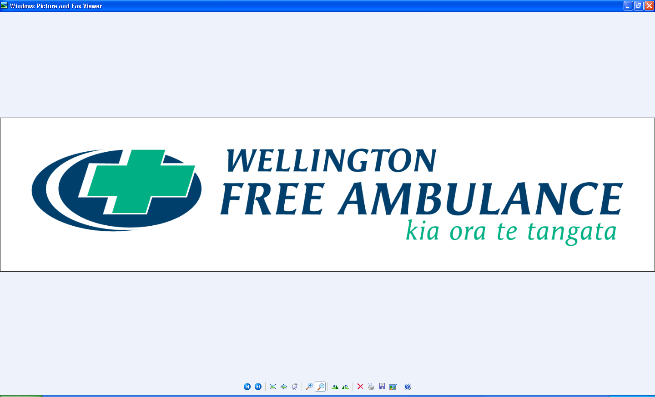

**JOB DESCRIPTION**

|  |  |
| --- | --- |
| **POSITION** | Project Coordinator |
| **BUSINESS UNIT** | Programme Delivery |
| **GROUP** | People & Enabling Services |
| **RESPONSIBLE TO**  **LAST UPDATED** | Head of Programme Delivery  September 2023 |

|  |
| --- |
| **Our Vision**  To be the best little ambulance service in the world.  **Our Belief**  To be here for you, when it matters to you, because it matters to us.  **Our Promise**  No decision about me without me  **Our Values**  **Values** |

JOB PURPOSE

The purpose of the Project Coordinator is to provide high quality end to end support to the programme delivery work programme. This role works within and across the team to provide regular reports and administration, keeping on top of implementation progress on some targeted aspects of the work and provides support to ensure that all Wellington Free Ambulance (WFA) projects and activities are delivered on-time, within scope and budget.

CONTEXT THAT THIS ROLE OPERATES WITHIN

**Organisational perspective**

WFA is the one and only paramedic service for Greater Wellington and the Wairarapa, and the only ones in the country who are free.

We are proud of the place we hold in our community, and the high quality, leading edge patient care that our people deliver every day. As well as emergency paramedic care, we provide patient transfer services; have paramedics who are part of the Life Flight crew and rescue squad, plus operate the 111 communications centre for our region.

Our area of operations extend from the Cook Strait to Peka Peka Road (past Waikanae) and across to Mount Bruce in the Wairarapa. We respond to on average 57,000 incidents per year. We have around 320 staff and 80 volunteers.

**Business Unit Perspective**

Programme Delivery operates within the broader People & Enabling Services function which includes, Commercial, Finance, Digital & Data, Performance, Reporting & Assurance, People & Capability and Health, Safety & Wellness. This role will work across all of WFA business groups and take a whole-organisation view of proposed initiatives and their impact on WFA.

As a broader function, People & Enabling Services are committed to be forward-looking, strategic in our decision making and confident enablers of our front-line services. A people focus underpins all work our support teams design and deliver, and together we translate the WFA strategy into positive actions and results.

### KEY ACCOUNTABILITIES

|  |  |
| --- | --- |
| **Key result area** | **Accountabilities** |
| **Project Coordination** Assist and support the Programme Delivery team to ensure WFA projects and activities are delivered on-time, within scope and budget. | * Coordinate across work plans to provide a programme wide view of progress, with a focus on improvements to achieve benefits * Actively monitor progress against delivery, identify inconsistencies and opportunities to provide additional guidance and support, as well as providing reporting on progress and/or issues * Track, identify and provide advice on emerging issues that pose potential risk, advising on priorities and focusing effort where it has the most impact * Coordinate research and information requests, ensuring source material is procured in a timely and accessible manner. * Undertake the day to day administration of business systems that support the teams governance and project and portfolio management * Assist in the preparing and drafting reports, briefings, communication plans, correspondence and other written materials and resources as needed * Provide Secretariat support for project, working, and implementation groups. Prepare agenda and minutes for meetings and maintain an actions log. |
| **Implementation Delivery** Support the design, development, delivery and management of communications for project implementations | * Implementation plans and associated logistical plans developed Communications plan and collateral developed and delivered on time and within budget * Stakeholders engaged throughout process * Business as usual is maintained during the transition * Business continuity plans are updated as required |
| **Administrative Support** | * Prepare and distribute papers and agendas for project and steering group meetings * Attend team and steering group meetings and take minutes * Working with the team, establish and maintain systems for collection, storage and retrieval of programme related documentation. * Scanning and compilation of responses to information requests |
| **Living WFA’s values:**  WFA is a values-based organisation, and employees should be committed to upholding our company values. Our values represent who we are, where we’re going and who we’re taking with us. | * Be authentic, original true | Mā pango mā whero ka oti te mahi * Act with kindness | Aroha atu, aroha mai * Lead by example | Mahia te mahi, hei painga mo te iwi * Keep getting better together | Whaia e koe te iti kahurangi |
| **Health and Safety:**  Complies with responsibilities under the Health and Safety at Work Act 2015.  In the performance of assigned duties, maintains a safe and healthy workplace and actively participates in WFA’s Health and Safety Management system. | * Actively support and comply with health and safety policy and procedures * Actively participate in the hazard identification and management process * Proactively report and remedy any unsafe work condition, accident or injury * Identify and report all job-related hazards * Follow all codes of practice, protocols and guidelines related to work practices * Report all accidents, incidents and near misses * Raise any issues of concern with manager as soon as possible * Model the purpose and ethos of the organisation by maintaining personal wellbeing |

Relationships and delegations

|  |  |  |
| --- | --- | --- |
| Reporting Structure | **Manager:** | Head of Programme Delivery |
| **Peers:** | Project Managers, Senior Advisor (Projects) |
| **Direct Reports:** | NIL |
| Key relationships | **Internal:** | Project teams, WFA staff, SLT |
| **External:** | Any external stakeholders and contractors involved in projects |
| Delegations & authorities | **Delegation Level:** | NIL |

### CAPABILITY PROFILE

Competencies

Competent performance in the role requires demonstration of the following competencies.

|  |  |
| --- | --- |
| Core Competency | Key Behaviours |
| **Situational Adaptability** | * Picks up on the need to change personal and interpersonal behaviours * Seamlessly adapts style to fit the specific needs of others |
| **Being Resilient** | * Stays focused and composed in stressful situations * Maintains a positive attitude and forward-thinking approach * Takes constructive action to navigate difficulties or obstacles |
| **Action Oriented** | * Readily takes action on challenges without necessary planning * Identifies and seizes new opportunities * Displays a positive can-do attitude in good and bad times * Steps up to handle tough issues |
| **Customer Focus** | * Is dedicated to meeting the expectations and requirements of internal and external stakeholders * Gets first-hand stakeholder information and uses it for improvements in products and services * Acts with stakeholders’ best interests in mind * Establishes and maintains effective relationships with stakeholders and gains their trust and respect |
| **Interpersonal Savvy** | * Relates comfortably with people of different levels, functions, cultures and locations * Acts with diplomacy and tact * Builds constructive relationships with people in an open, friendly and accepting way * Picks up on interpersonal and group dynamics |
| **Instils Trust** | * Follows through on commitments * Is seen as a trusted individual, who can maintain confidentiality * Accepts accountability for their actions * Doesn’t misrepresent her/himself for personal gain |
| **Communicates Effectively** | * Delivers messages in a clear, compelling, and concise manner * Actively listens and checks for understanding * Adjusts communication content and style to meet the needs of diverse stakeholders * Models and encourages the expression of diverse ideas and opinions |
| **Te Tiriti o Waitangi and Cultural Expertise** | * Demonstrates understanding of the principles of te Tiriti o Waitangi and their contemporary application to WFA’s work * Applies tikanga in relevant work situations |
| **Cultural Competencies** | * Wellington Free Ambulance is committed to its responsibility to Maori and its responsibility to Pasifika. In that regard there is an expectation of continued learning and development of all staff in this area. |

Other aspects of capability not covered by the above competencies

Knowledge and Experience:

|  |  |
| --- | --- |
| Essential | Desirable |
| * 2+ years’ project coordination experience or similar skill set * Knowledge or qualification in project management * Proficient in the Microsoft suite – Word, Excel, PowerPoint etc. * Exceptional communication skills, both written and verbal * Organised with a natural inclination for planning strategy and tactics * Excellent time management skills * Experience developing and implementing training plans * Ability to work with people across all levels of an organisation. * Able to work independently and manage own tasks | * Health sector knowledge * Proficient in the full Microsoft suite including Microsoft Project and Visio * Experience and knowledge of project management principles, methodologies and tools |

Other:

Hours of Work

The normal working week will *be Monday to Friday; however the nature of the duties may require work outside the normal hours from time to time.*

Changes to Job Description

From time to time as an organisation evolves job descriptions may need to be reviewed and may need to be changed. Such changes may be initiated as necessary by the manager of this position in consultation with the employee. This job description may also be reviewed as part of the preparation for performance planning for the annual performance cycle.

Employees may be measured against core competencies as part of their performance development.